**Daily Change in Settlement (Bps)**

The following histograms illustrate the daily change in settlement of ED futures in the past 5 years.

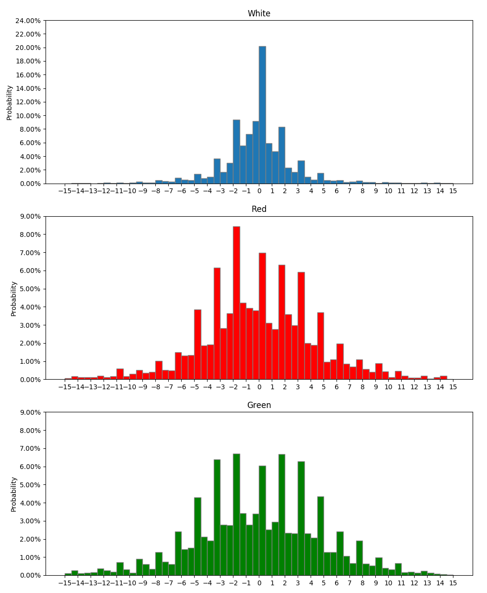

The probabilities are summarized in the table below:

|  |  |  |  |
| --- | --- | --- | --- |
|  | White | Red | Green |
| Between -2bp to 2bp | 69.88% | 38.78% | 33.99% |
| Between -5bp to 5bp | 91.54% | 78.30% | 73.38% |
| Less than -5bp | 4.38% | 10.39% | 12.88% |
| More than 5bp | 4.10% | 11.33% | 13.76% |
| Less than -10bp | 0.96% | 2.79% | 3.10% |
| More than 10bp | 1.24% | 2.51% | 2.75% |
| Average move | -0.0181bp | 0.0053bp | 0.0201bp |

**Comparison between Positive and Negative 10bp Move within Group**

**White:** Rates move 1 day after more than 10bp and less than -10bp move

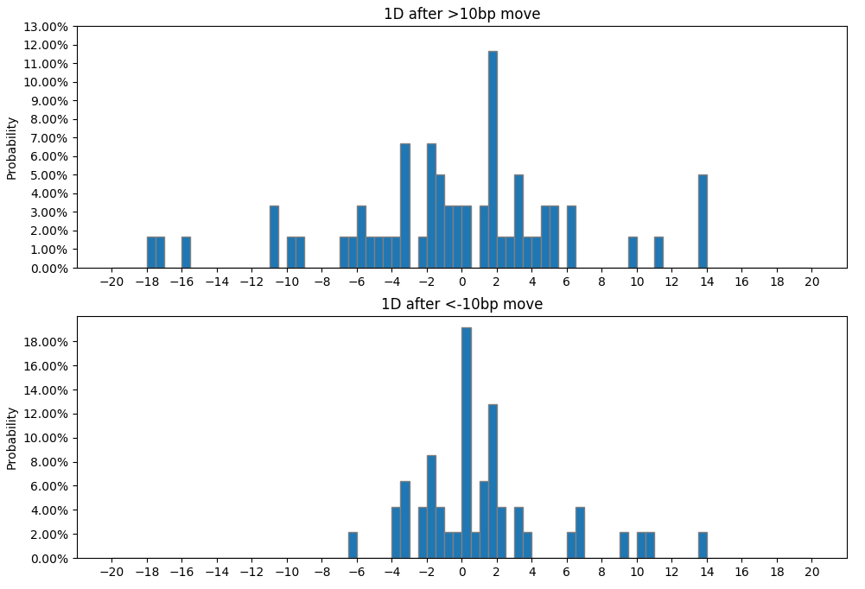

The probabilities are summarized in the table below:

|  |  |  |
| --- | --- | --- |
|  | >10bp | <-10bp |
| Between -2bp to 2bp | 36.67% | 57.45% |
| Between -5bp to 5bp | 65.00% | 76.60% |
| Less than -5bp | 21.67% | 2.13% |
| More than 5bp | 15.00% | 14.89% |
| Less than -10bp | 10.00% | 0.00% |
| More than 10bp | 6.67% | 6.38% |
| Average move | -0.86bp | -1.16bp |

**Red:** Rates move 1 day after more than 10bp and less than -10bp move

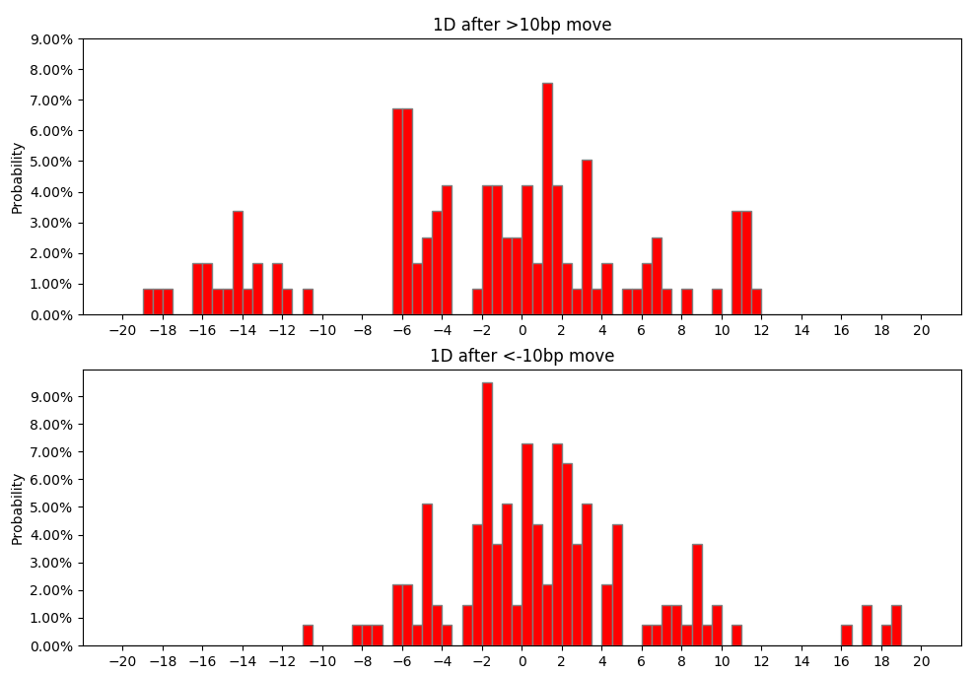

The probabilities are summarized in the table below:

|  |  |  |
| --- | --- | --- |
|  | >10bp | < -10bp |
| Between -2bp to 2bp | 30.33% | 40.88% |
| Between -5bp to 5bp | 50.82% | 75.91% |
| Less than -5bp | 34.43% | 8.03% |
| More than 5bp | 15.57% | 16.06% |
| Less than -10bp | 19.67% | 0.73% |
| More than 10bp | 7.38% | 5.11% |
| Average move | -2.74bp | 1.39bp |

**Green:** Rates move 1 day after more than 10bp and less than -10bp move

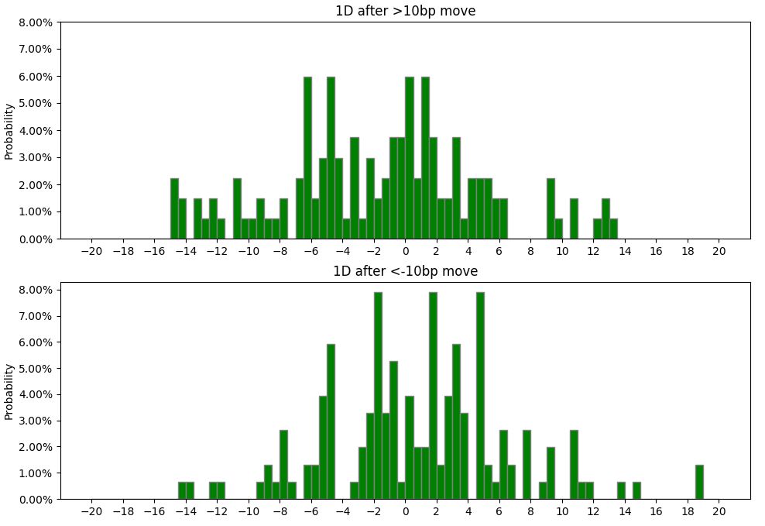

The probabilities are summarized in the table below:

|  |  |  |
| --- | --- | --- |
|  | >10bp | <-10bp |
| Between -2bp to 2bp | 29.10% | 32.89% |
| Between -5bp to 5bp | 58.21% | 67.11% |
| Less than -5bp | 29.85% | 15.13% |
| More than 5bp | 12.69% | 17.76% |
| Less than -10bp | 11.94% | 2.63% |
| More than 10bp | 4.48% | 6.58% |
| Average move | -1.81bp | 0.85bp |

**Comparison Across Groups**

1 Day After More Than 10bp Move

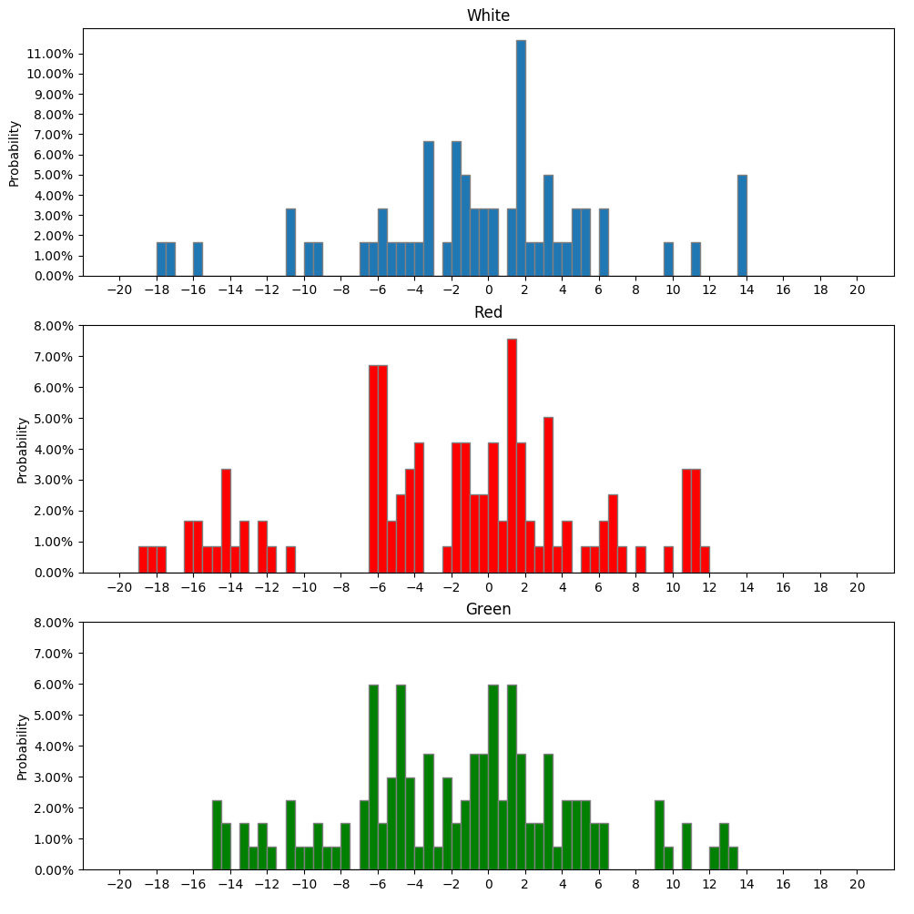

The probabilities are summarized in the table below:

|  |  |  |  |
| --- | --- | --- | --- |
|  | White | Red | Green |
| Between -2bp to 2bp | 36.67% | 30.33% | 29.10% |
| Between -5bp to 5bp | 65.00% | 50.82% | 58.21% |
| Less than -5bp | 21.67% | 34.43% | 29.85% |
| More than 5bp | 15.00% | 15.57% | 12.69% |
| Less than -10bp | 10.00% | 19.67% | 11.94% |
| More than 10bp | 6.67% | 7.38% | 4.48% |
| Average move | -0.86bp | -2.74bp | -1.81bp |

1 Day After Less Than -10bp Move

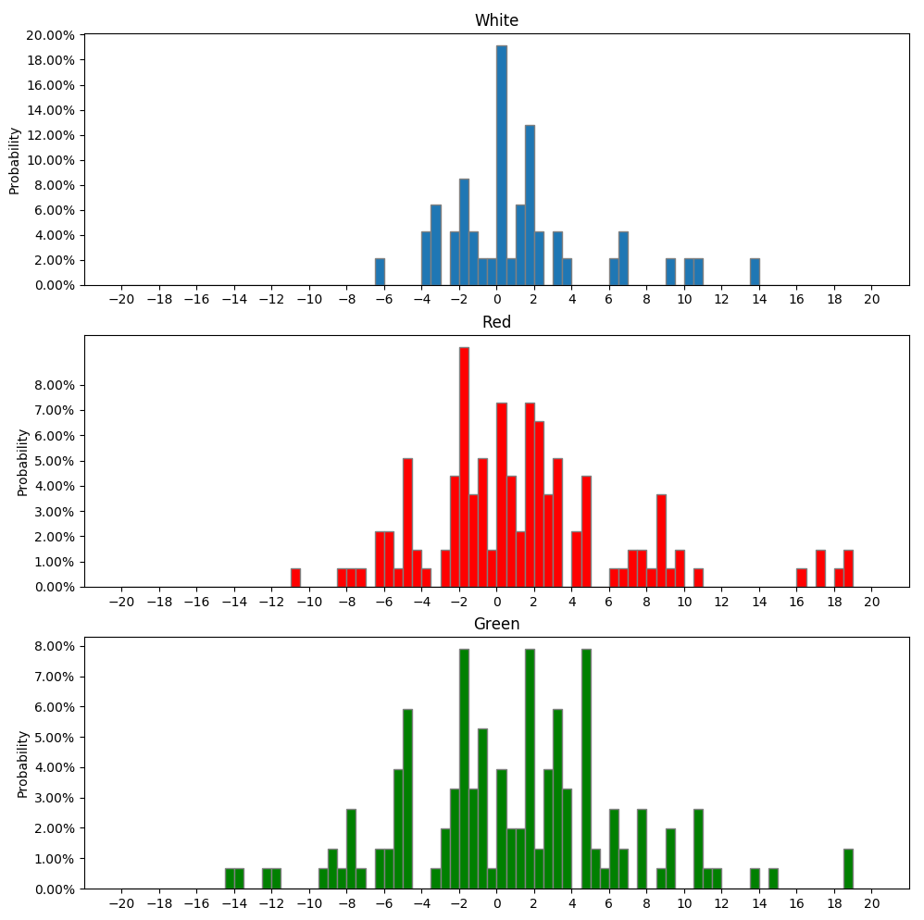

The probabilities are summarized in the table below:

|  |  |  |  |
| --- | --- | --- | --- |
|  | White | Red | Green |
| Between -2bp to 2bp | 57.45% | 40.88% | 32.89% |
| Between -5bp to 5bp | 76.60% | 75.91% | 67.11% |
| Less than -5bp | 2.13% | 8.03% | 15.13% |
| More than 5bp | 14.89% | 16.06% | 17.76% |
| Less than -10bp | 0.00% | 0.73% | 2.63% |
| More than 10bp | 6.38% | 5.11% | 6.58% |
| Average move | 1.16bp | 1.39bp | 0.85bp |